Date | 20 Feb 2026
Team ID | LTVIP2026TMIDS24859
Project Name | Calculate Family Expenses using Service Now
Mentor Name | Dr Shaik Salma Begum
Maximum Marks | 10 Marks

Calculate Family Expenses
Objective
The objective of performance testing is to ensure that the Family Expense Management System performs efficiently when handling multiple expense records. It verifies that data insertion, business rules, relationships, and automatic calculations work correctly without delays or errors.

Milestone 1: Setting Up ServiceNow Instance:
- Sign up on developer.servicenow.com and create a developer account.
- Navigate to the Personal Developer Instance section and request a new instance.
- Fill out the required information and submit the request.
- Instance details (URL, username, password) will be sent via email.
- Log in to the instance using the provided credentials.
- The instance is ready for development and customization.
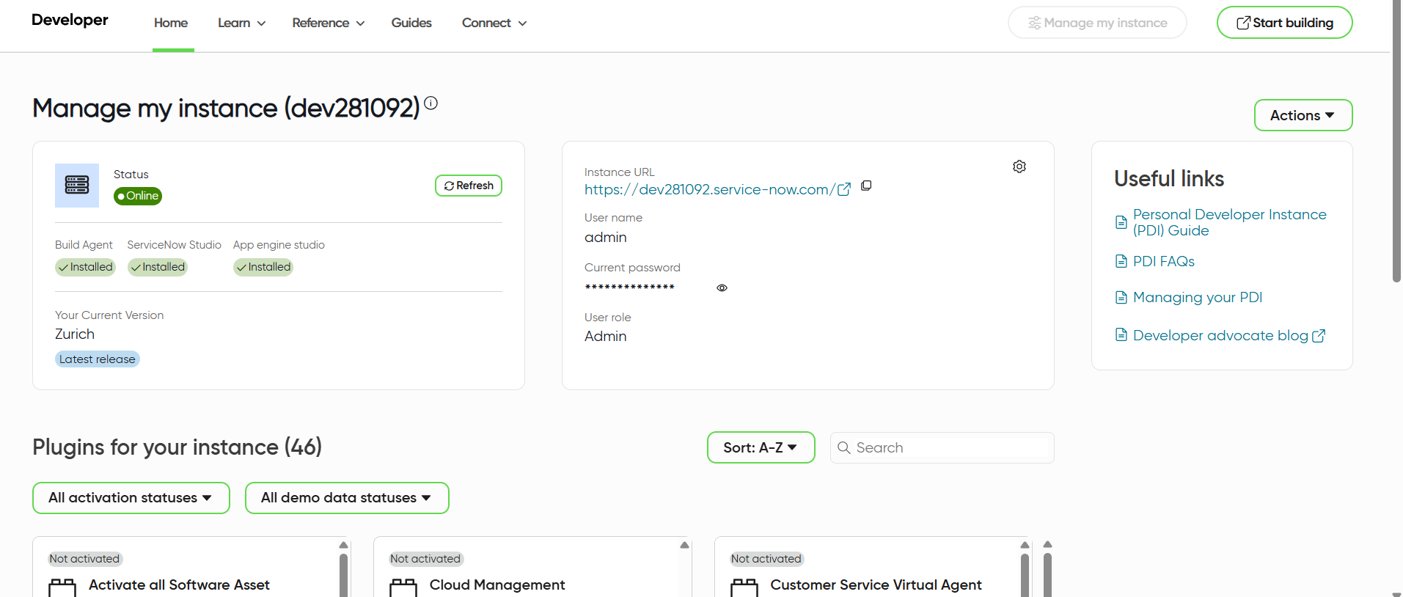
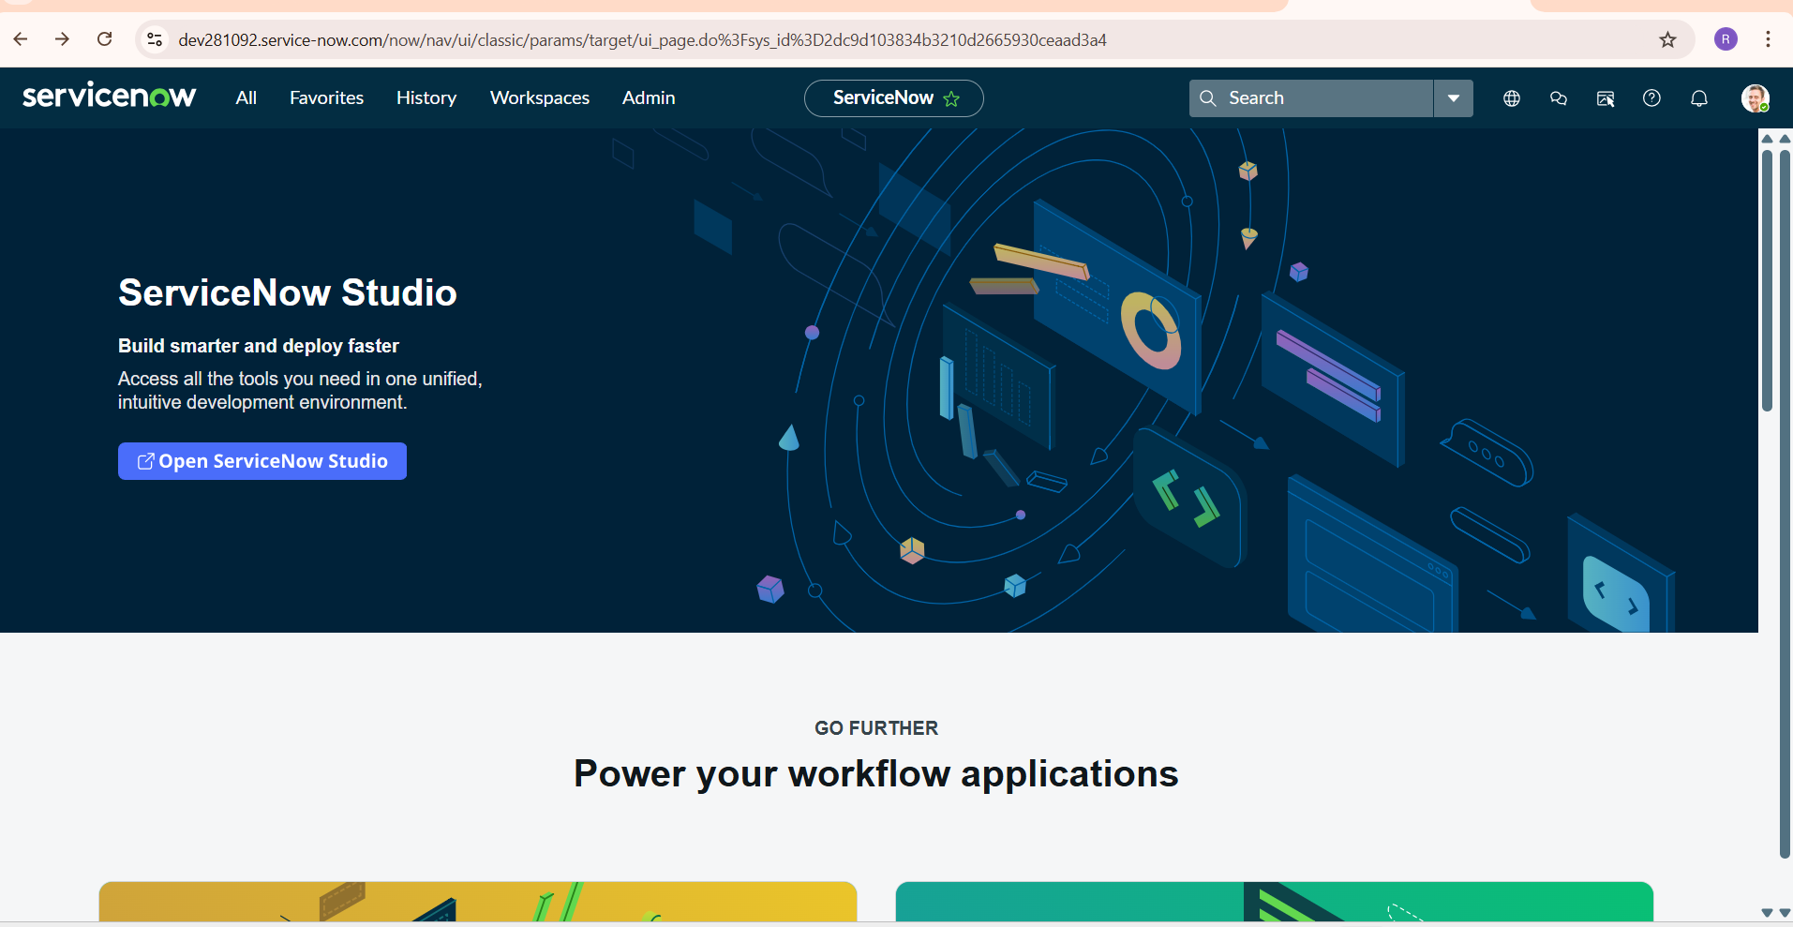

Milestone 2: Creation of Table (Family Expenses):
- Navigate to All in the application navigator.
- In the filter search bar, type Tables and select it from the results.
- Click on the New button to create a new table.
- In the form, provide the following details:
- Label: Family Expenses
- Name: Auto-populated
- New menu name: Family Expenditure
- Navigate to the header section of the form, right-click on the header, and select Save.
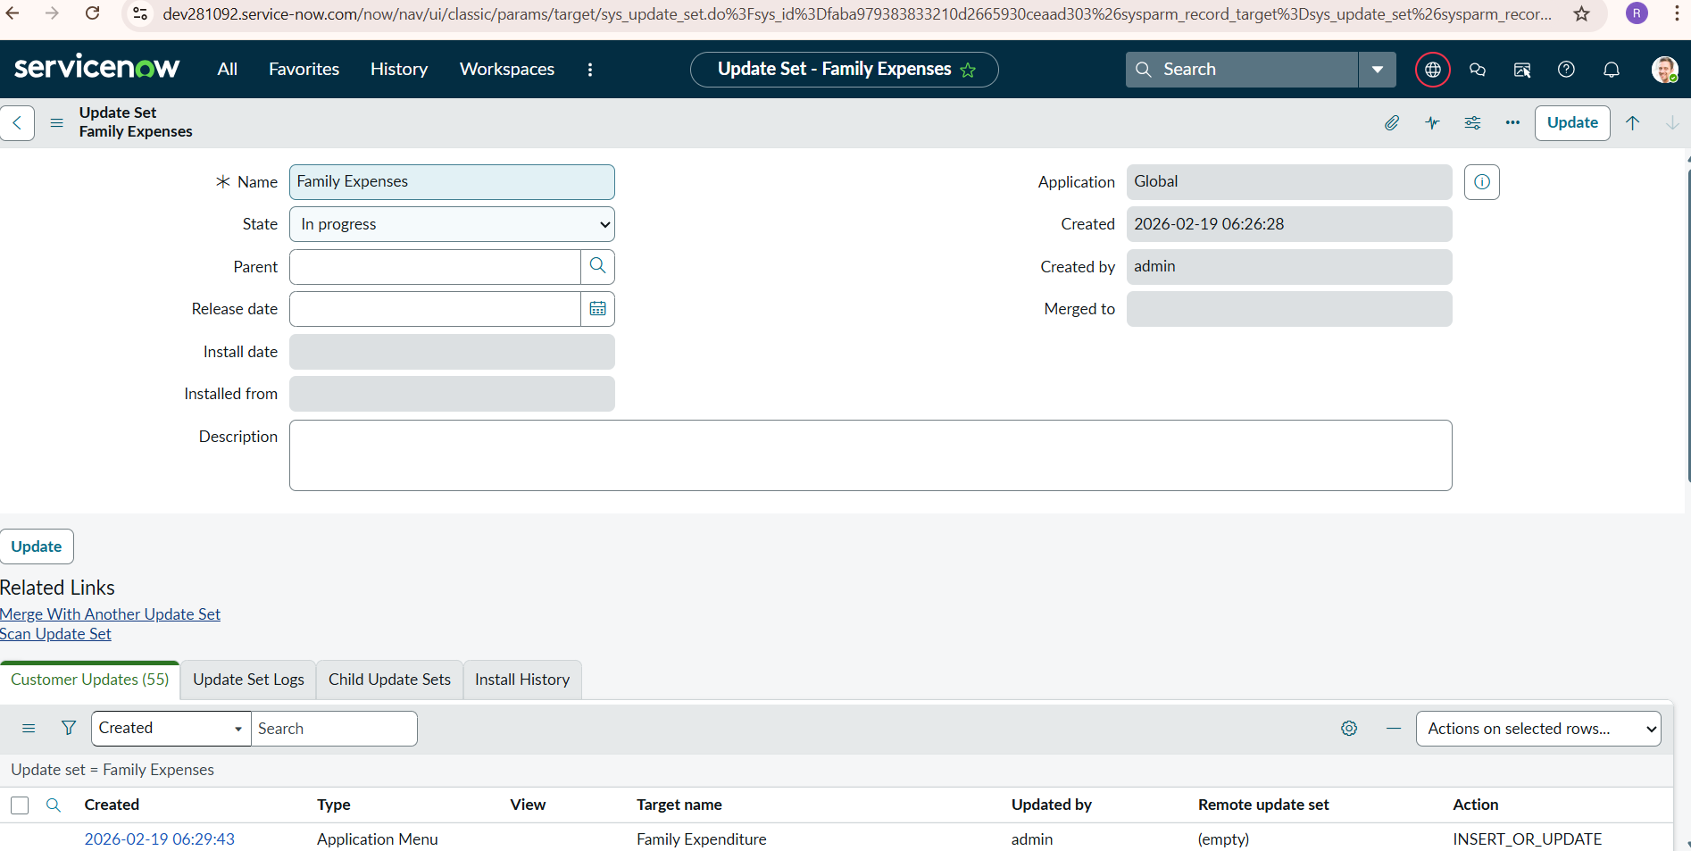

Milestone 3: Creation of Fields (Family Expenses):
After saving the table scroll down
- Create the following fields
- Number : String
- Date : Date
- Amount : Integer
- Expense Details : String
- Click Save
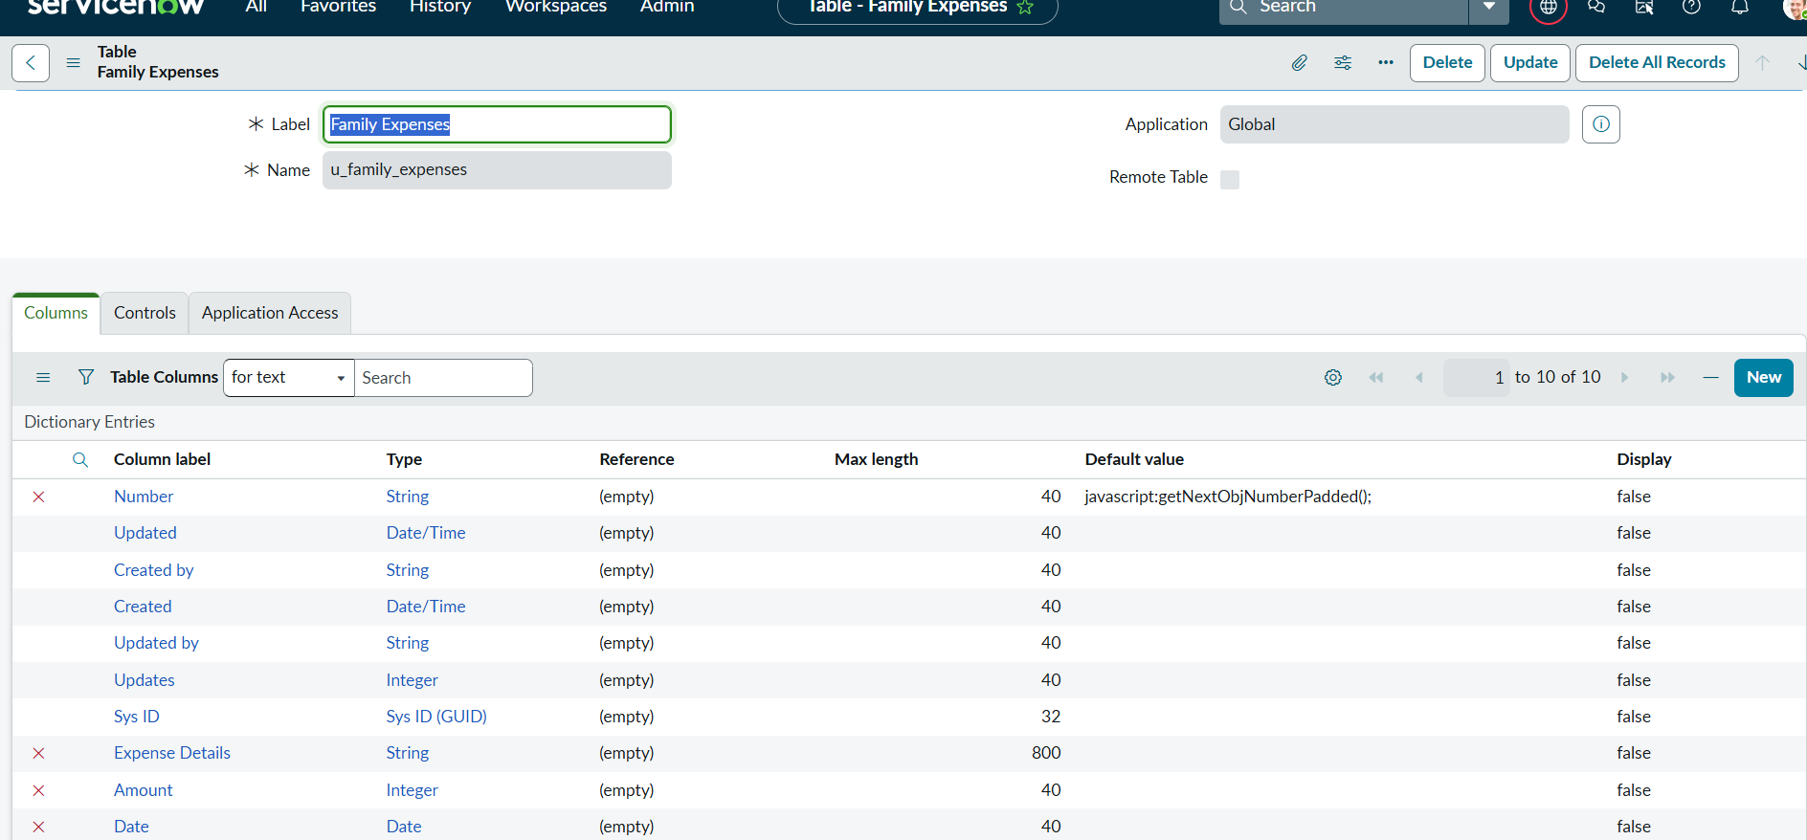

Milestone 4: Creation of Table (Daily Expenses):
- Navigate to Tables in the application navigator.
- Click on New.
- Provide the following details:
  - Label: Daily Expenses
  - Name: Auto-populated
  - Add menu to: Family Expenditure
- Click Save.
Create the following fields:
- Number : String
- Date : Date
- Expense : Integer
- Family Member Name : Reference (Family Expenses)
- Comments : String
Click Save
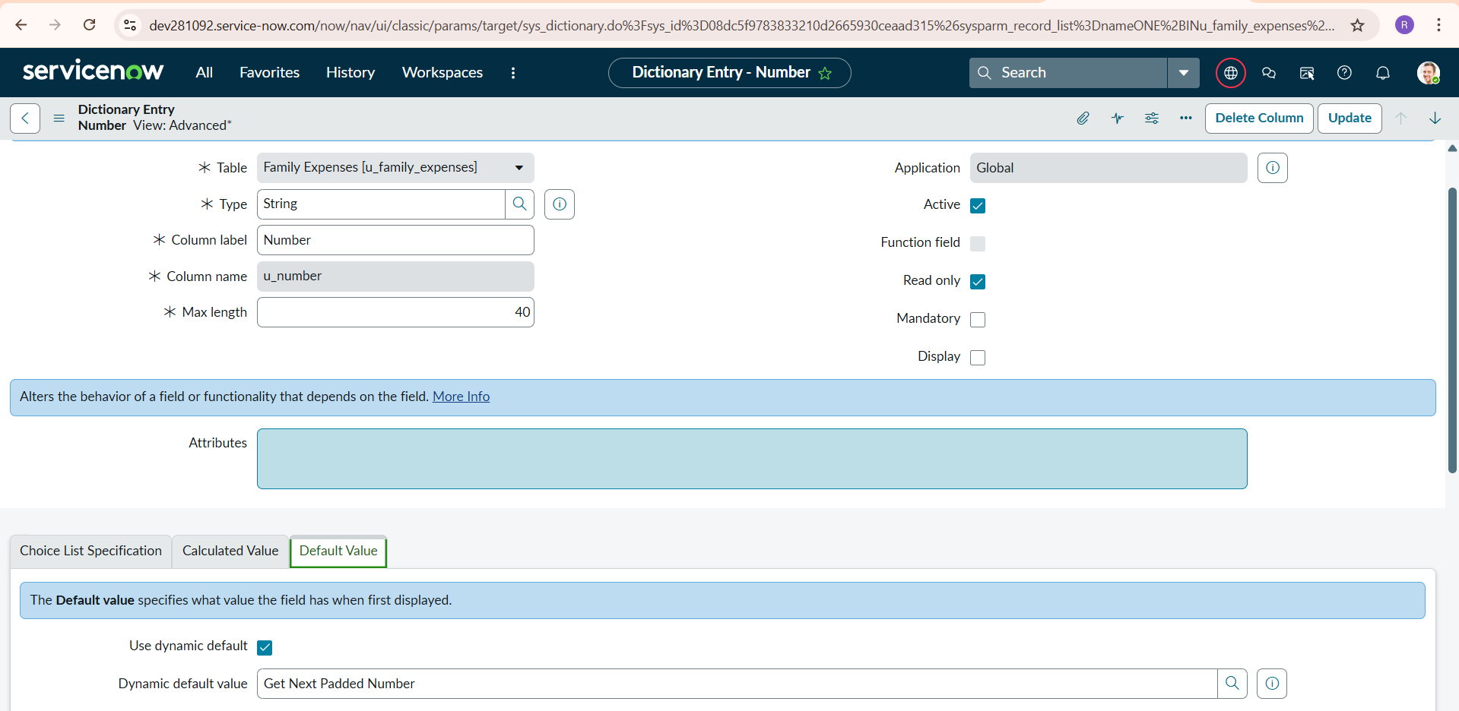

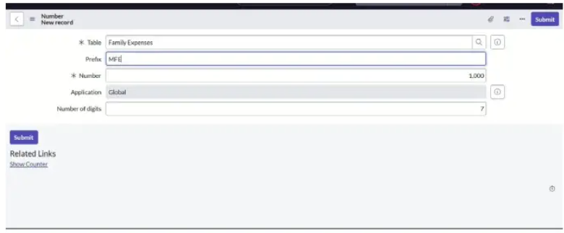

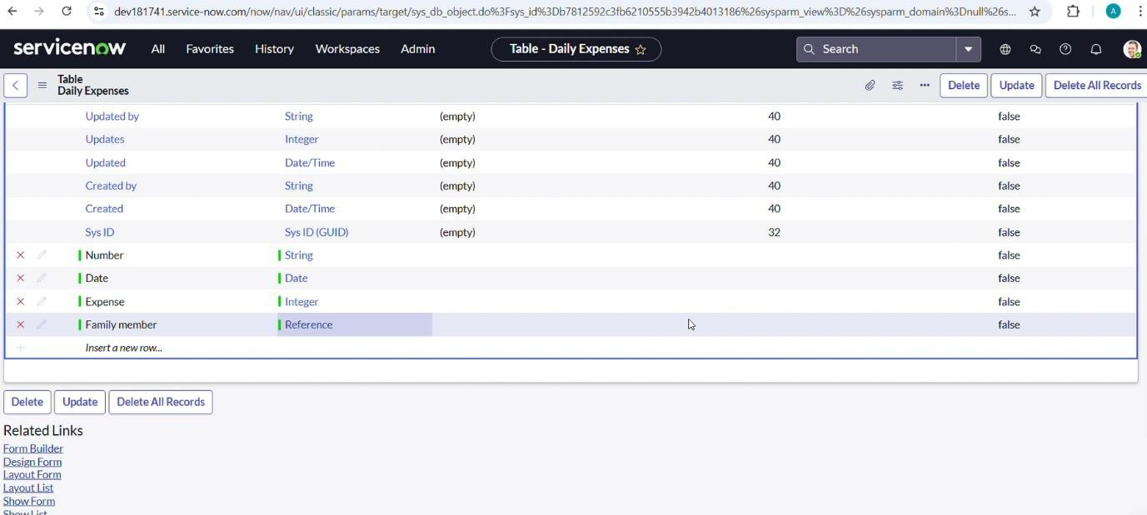

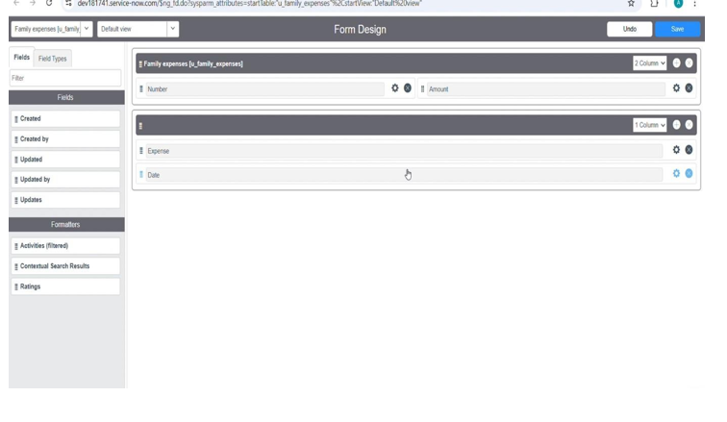

Milestone 5: Creation of Relationship:
- Navigate to System Definition → Relationships
- Click New
- Fill the following details:
  - Name: Daily Expenses
  - Applies to Table: Family Expenses
  - Related List Table: Daily Expenses
- Click Submit
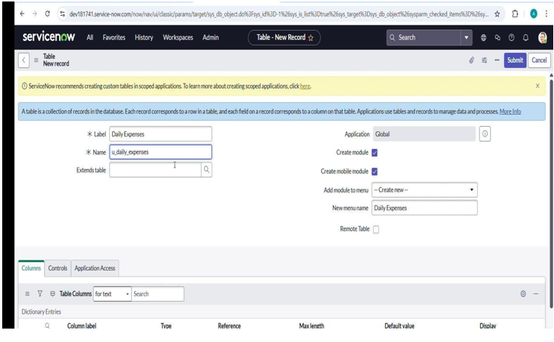
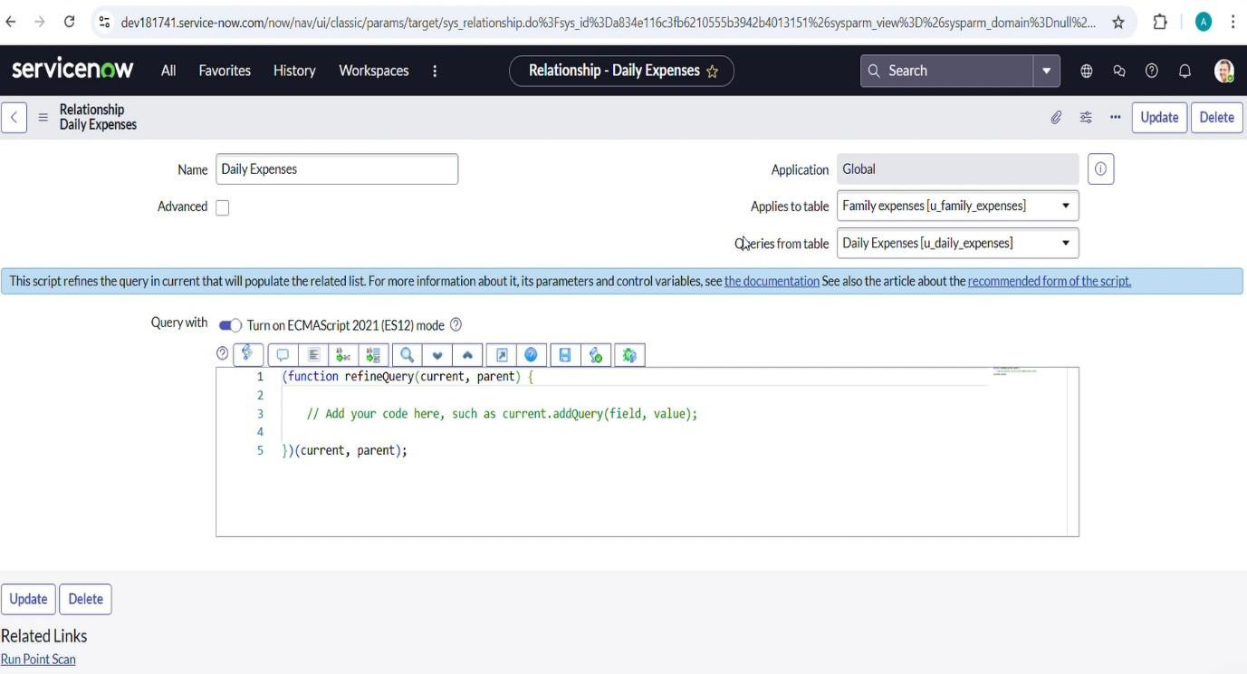
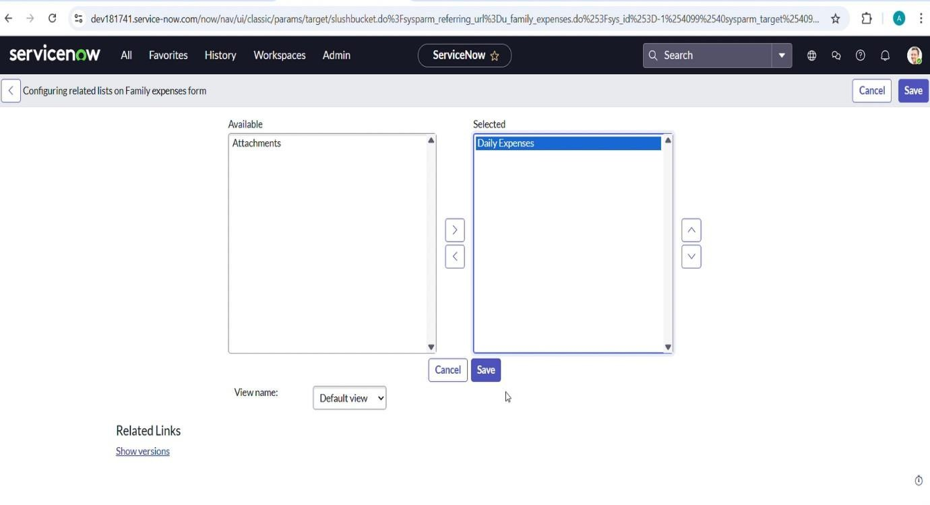
Milestone 6: Creation of Business Rule:
- Navigate to System Definition → Business Rules
- Click New
- Fill the following details:
  - Name: Family Expenses Business Rule
  - Table: Daily Expenses
  - When: Before
  - Insert: Checked
  - Update: Checked
- Add the script:
(function executeRule(current, previous) {
var family = new GlideRecord('u_family_expenses');
family.addQuery('u_date', current.u_date);
family.query();
if (family.next()) {
family.u_amount = parseInt(family.u_amount) + parseInt(current.u_expense);
family.u_expense_details = family.u_expense_details +
">" + current.u_comments + ":Rs." + current.u_expense;
family.update();
}
else {
var newFamily = new GlideRecord('u_family_expenses');
newFamily.initialize();
newFamily.u_date = current.u_date;
newFamily.u_amount = current.u_expense;
newFamily.u_expense_details =
">" + current.u_comments + ":Rs." + current.u_expense;
newFamily.insert();
}
})(current, previous);
Click Submit
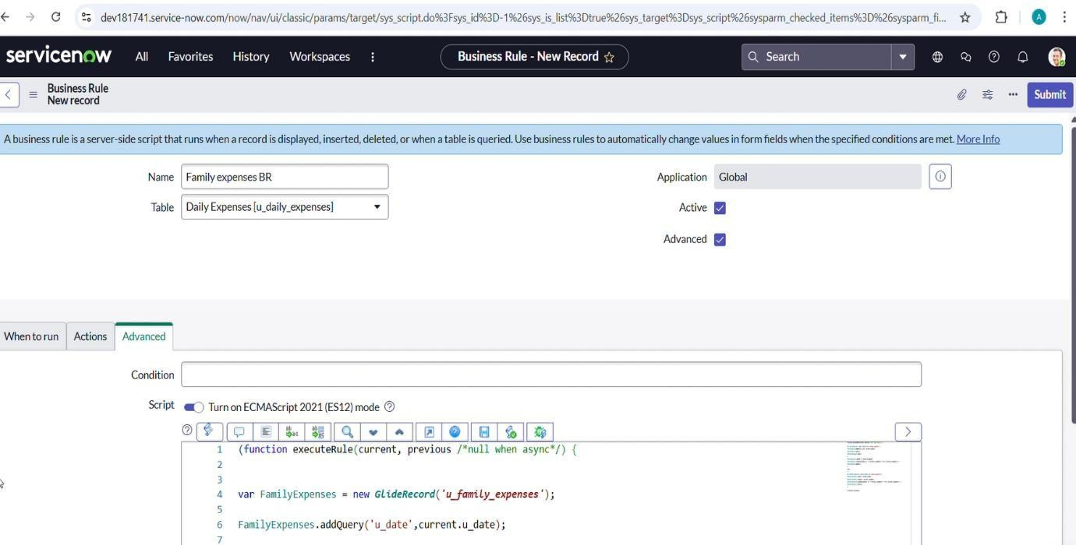

Milestone 7: Creation of Relationship Query Script:
- Navigate to System Definition → Relationships
- Open Daily Expenses relationship
- Check Advanced
- In Query with section, enter:
(function refineQuery(current, parent) {
current.addQuery('u_date', parent.u_date);
current.query();
})(current, parent);
Click Update
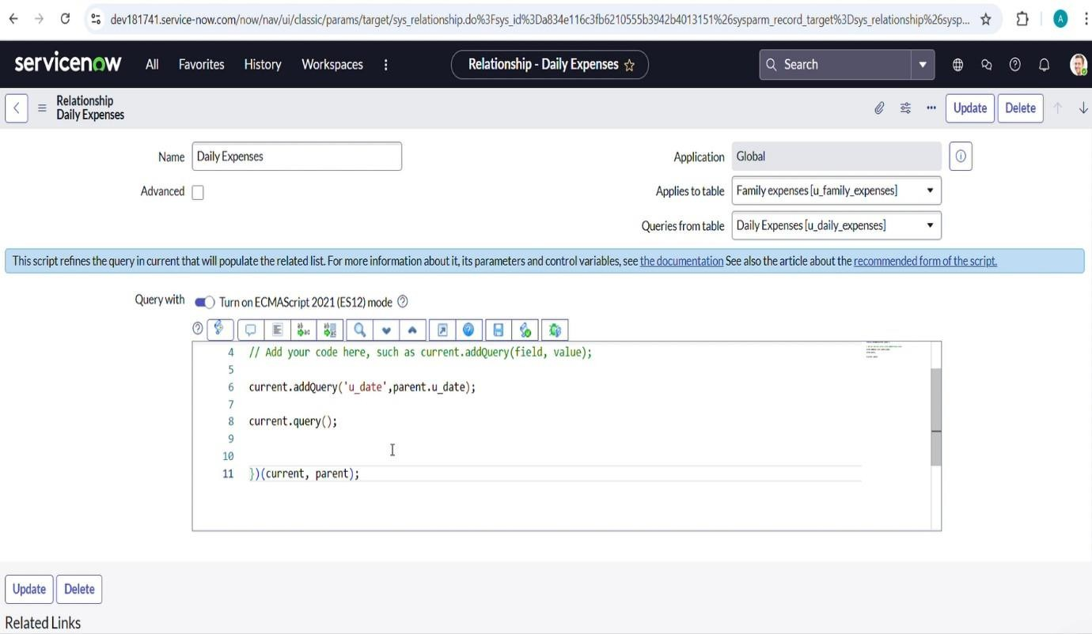
Milestone 8: Testing of Family Expenses Application:
- Navigate to All → Daily Expenses
- Click New
- Enter details:
  - Date: 20-02-2026
  - Expense: 500
  - Family Member Name: Select record
  - Comments: Food Expense
- Click Submit
Verification:
- Navigate to Family Expenses
- Check that Amount is automatically updated
- Check Expense Details is automatically updated
- Verify related Daily Expenses records are displayed





